PL/SQL Control Structures

# Scenario 1: Discount for Senior Citizens

The bank wants to apply a discount to loan interest rates for customers above 60 years old.  
  
PL/SQL Block:

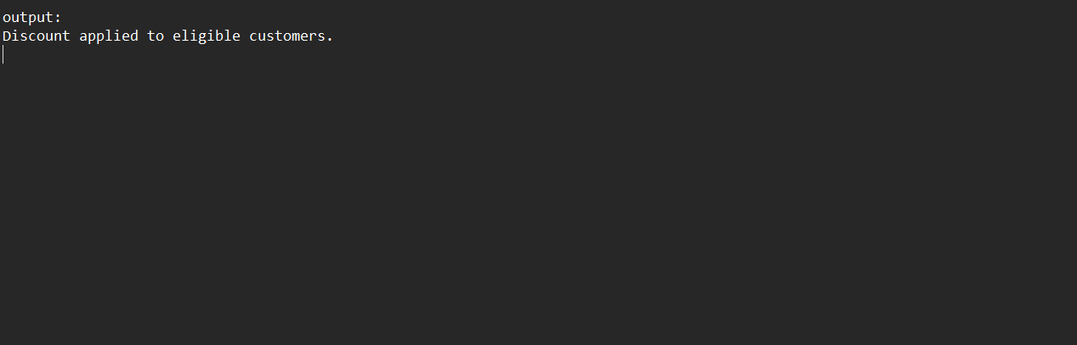  
DECLARE  
 CURSOR cur_customers IS  
 SELECT CustomerID, InterestRate, Age FROM Customers;  
BEGIN  
 FOR cust IN cur_customers LOOP  
 IF cust.Age > 60 THEN  
 UPDATE Customers  
 SET InterestRate = InterestRate - 1  
 WHERE CustomerID = cust.CustomerID;  
 END IF;  
 END LOOP;  
 COMMIT;  
 DBMS_OUTPUT.PUT_LINE('Discount applied to eligible customers.');  
END;

# Scenario 2: Promote to VIP Status

A customer can be promoted to VIP status based on their balance.  
  
PL/SQL Block:

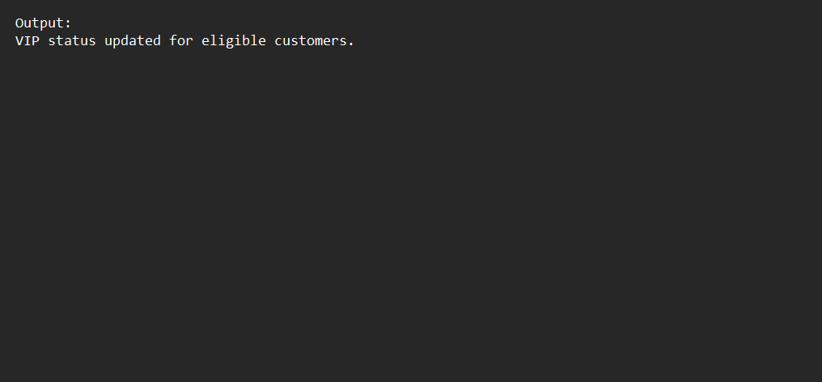  
DECLARE  
 CURSOR cur_customers IS  
 SELECT CustomerID, Balance FROM Customers;  
BEGIN  
 FOR cust IN cur_customers LOOP  
 IF cust.Balance > 10000 THEN  
 UPDATE Customers  
 SET IsVIP = 'TRUE'  
 WHERE CustomerID = cust.CustomerID;  
 END IF;  
 END LOOP;  
 COMMIT;  
 DBMS_OUTPUT.PUT_LINE('VIP status updated for eligible customers.');  
END;

# Scenario 3: Loan Due Reminders

The bank wants to send reminders to customers whose loans are due within the next 30 days.  
  
PL/SQL Block:

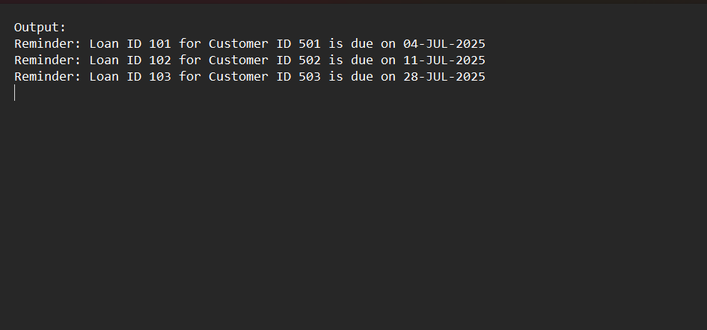  
DECLARE  
 CURSOR cur_loans IS  
 SELECT LoanID, CustomerID, DueDate FROM Loans  
 WHERE DueDate BETWEEN SYSDATE AND SYSDATE + 30;  
BEGIN  
 FOR loan IN cur_loans LOOP  
 DBMS_OUTPUT.PUT_LINE('Reminder: Loan ID ' || loan.LoanID ||  
 ' for Customer ID ' || loan.CustomerID ||  
 ' is due on ' || TO_CHAR(loan.DueDate, 'DD-MON-YYYY'));  
 END LOOP;  
END;